**SmartTree Electrical System Installation Instruction**

**(for contractor’s reference)**

Author: Francis Chen

Co-PM, Electrical Lead

July 20th 2016

Table of Content

1. System Overview
   1. Usage Overview
   2. Block Diagram
   3. Physical Arrangement
   4. Point to Point Schematic
2. Installation
   1. Wiring
   2. Weather Proof and Insulation
      1. Solar Panel
      2. Battery box
      3. Wiring Raceway
      4. AC Outlet
   3. Grounding
3. System Overview

*This brief introduction is intended for illustrating the high level design. Refer to the full Electrical System Design Documentation for more detailed design for each individual part.*

* 1. Usage Overview

The SmartTree is a solar powered charging station that resembles the shape of a tree and provides a unique outdoor gathering place for students without worrying about their electronic devices running out of power. The *8 solar panels* will power a small off-grid system with *12 lead acid batteries* for energy storage. With proper voltage conversion, the system will output *2 AC outlets* and *4 USB ports*, for personal electronics like laptop, tablet, phones, etc., In addition, a screen will be mounted on the trunk to display the energy generation from the sun and promote the usage of renewable energy.

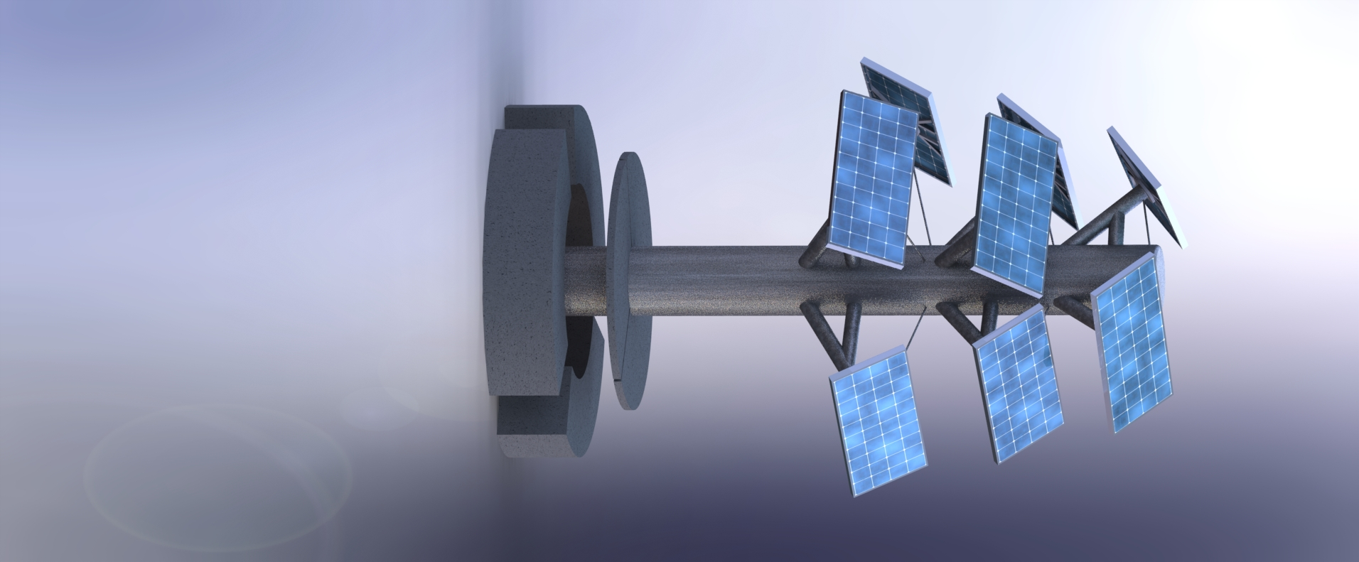

Figure 1.1 SmartTree CAD Model

* 1. Block Diagram

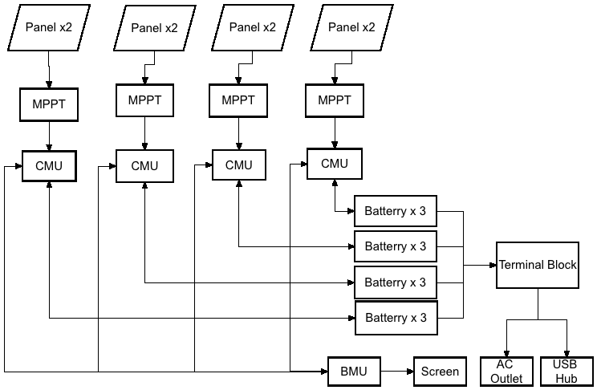

Figure 1.2 System Block Diagram

The overall system of the SmartTree consists of **8 solar panels,** each operating at **17V/75 W max power.** We paired up **every two of them** to form a subsystem, with **three serially connected 12V lead acid batteries** to store redundant energy and power the user output. Within every subsystem, a **maximum power point tracker (MPPT)** is implemented between the solar panels and the batteries to maximize the efficiency of the solar panel and regulate the voltage goes to the batteries. A **battery management system (BMS) consists of 4 CMUs and 1 BMU** is designed and implemented to monitor the state of the batteries, control the charging and discharging and displays energy savings on the screen. The four battery packs are all connected to a **36V terminal block** in parallel, which in turn powers **an inverter**, **a 36V-12V DC-DC converter** and **a 36V-5V DC-DC converter**. The inverter will provide the AC output, the 5V will power the USB ports, and the 12V will power the electronics within the system (i.e. BMS, Screen..etc.,).

* 1. Physical Arrangement

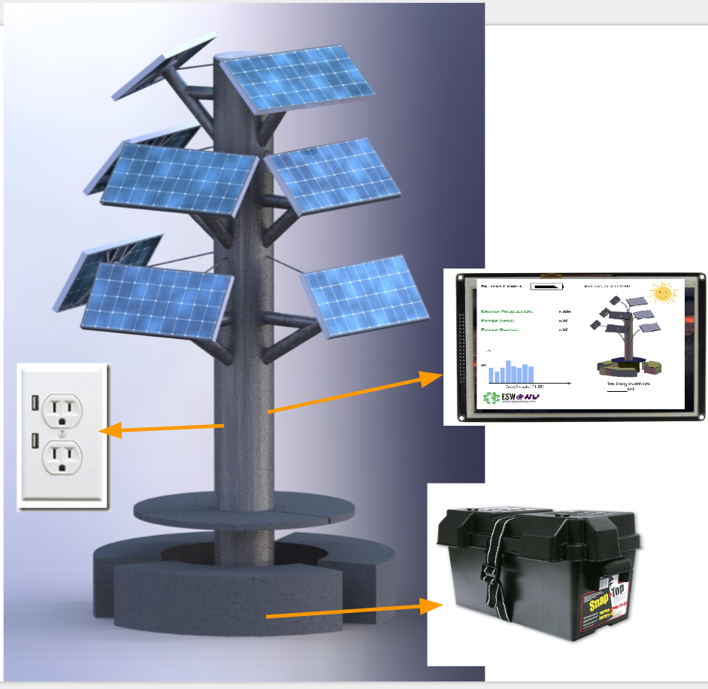

Figure 1.3 Physical Arrangements of Components

As shown in Figure 1.3, all the components except the solar panels, AC/USB outlets, and screen are housed within battery boxes. Solar panels are mounted at the end of the branches to collect sunlight. AC/USB outlets as well as the screen are mounted on the trunk, connecting with the battery boxes via wires running through the trunk. All the rest of the components, including battery, BMS, MPPT, inverter, DC-DC converters are all housed in five battery boxes, among which four houses batteries and one carries the control circuitry. Battery boxes are placed underground, underneath the table and benches. Individual components will be introduced in the next section.

* 1. Point to Point Schematic

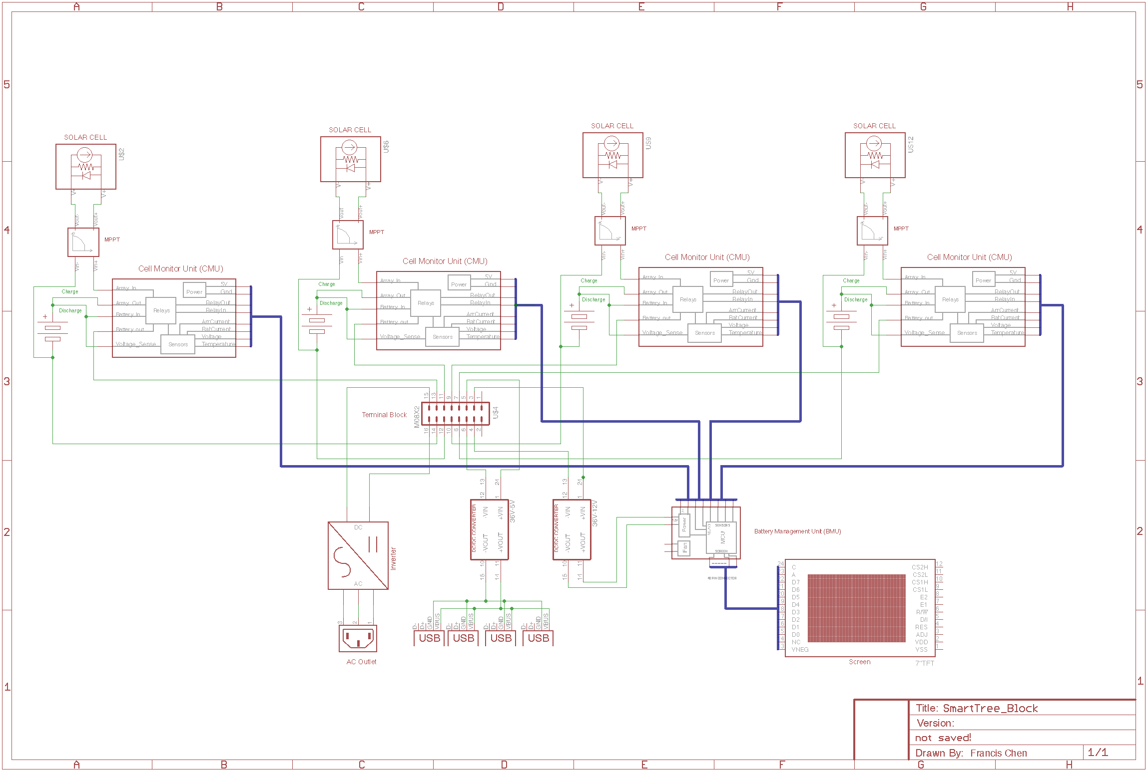

Figure 1.4 Point to Point Connections of SmartTree Electrical System

2. Installation

2.1. Battery box configuration

For the four battery boxes, installation shouldn’t require opening the box. As shown in the picture below, the three major connections battery box need to make is: Battery Output, Solar Array Input, and BMS Signal. Due to the quality of the picture, the wiring labels are not legible, but each wires are labeled with their functionality. The specific connections are detailed in the next section.

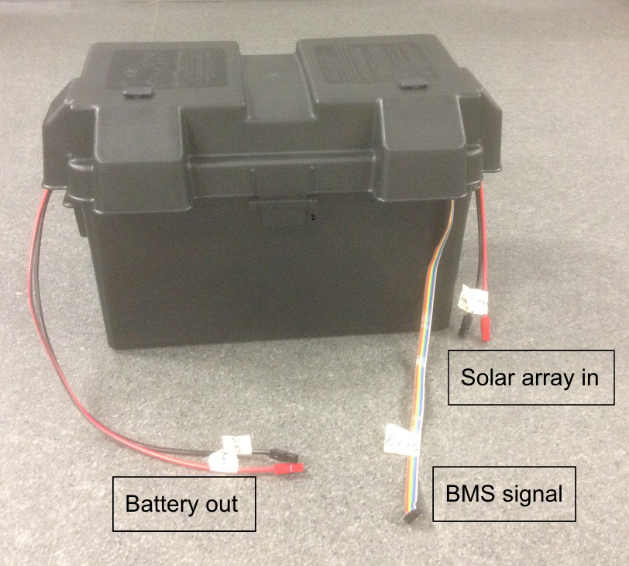

Figure 2.1 Battery box connections

For the control box, connections need to be made for the following component: Switch box, BMU board, inverter, AC outlet, 5V-DC-DC Converter and USB outlet. The detailed connection is documented in the next section.

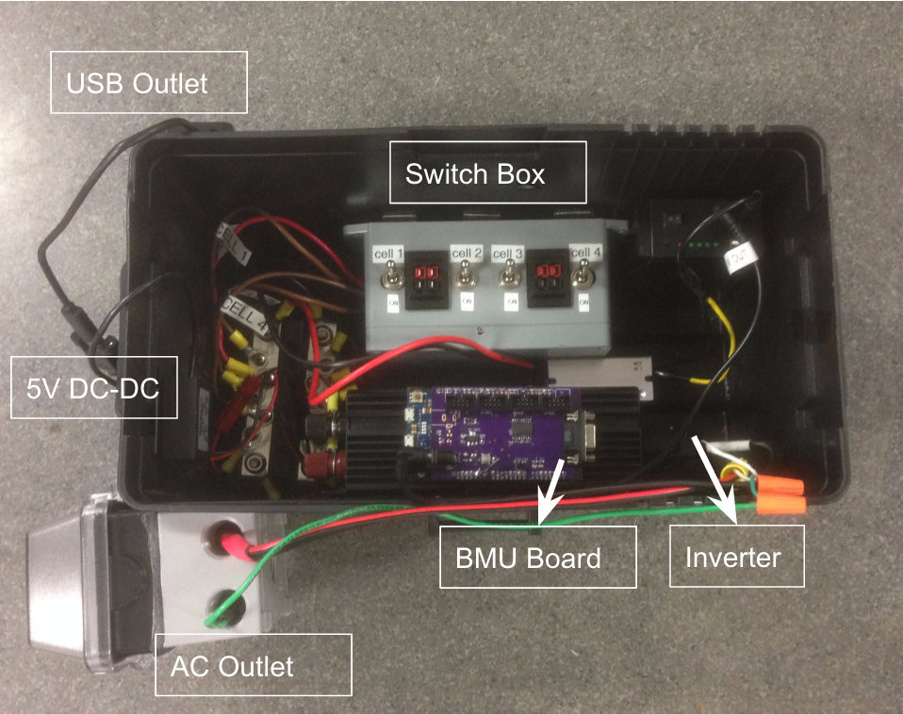

Figure 2.1 Center control box connections

2.2. Wiring

The installation of the electrical system requires the connection between the following components. Connections are shown both in terms of schematic and the real world picture. In schematic, if other wirings are present, the connection is highlighted with red marking.

1. Solar panels <-> Battery Box MPPT Input - PV cable (M4 connector to Anderson)

*On schematic*

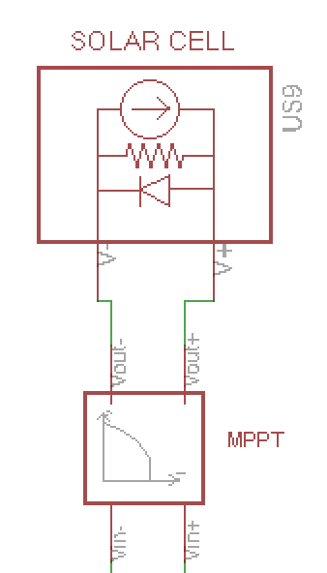

*In Picture*

[TODO: Add picture]

1. Battery box battery output <-> control box switch box - Anderson to Anderson

Note four of these connections should be made from four battery boxes to the central control box.

*On Schematic*

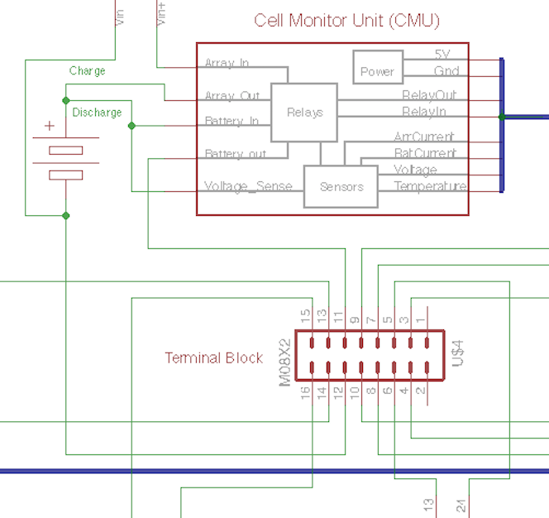

*In Picture*

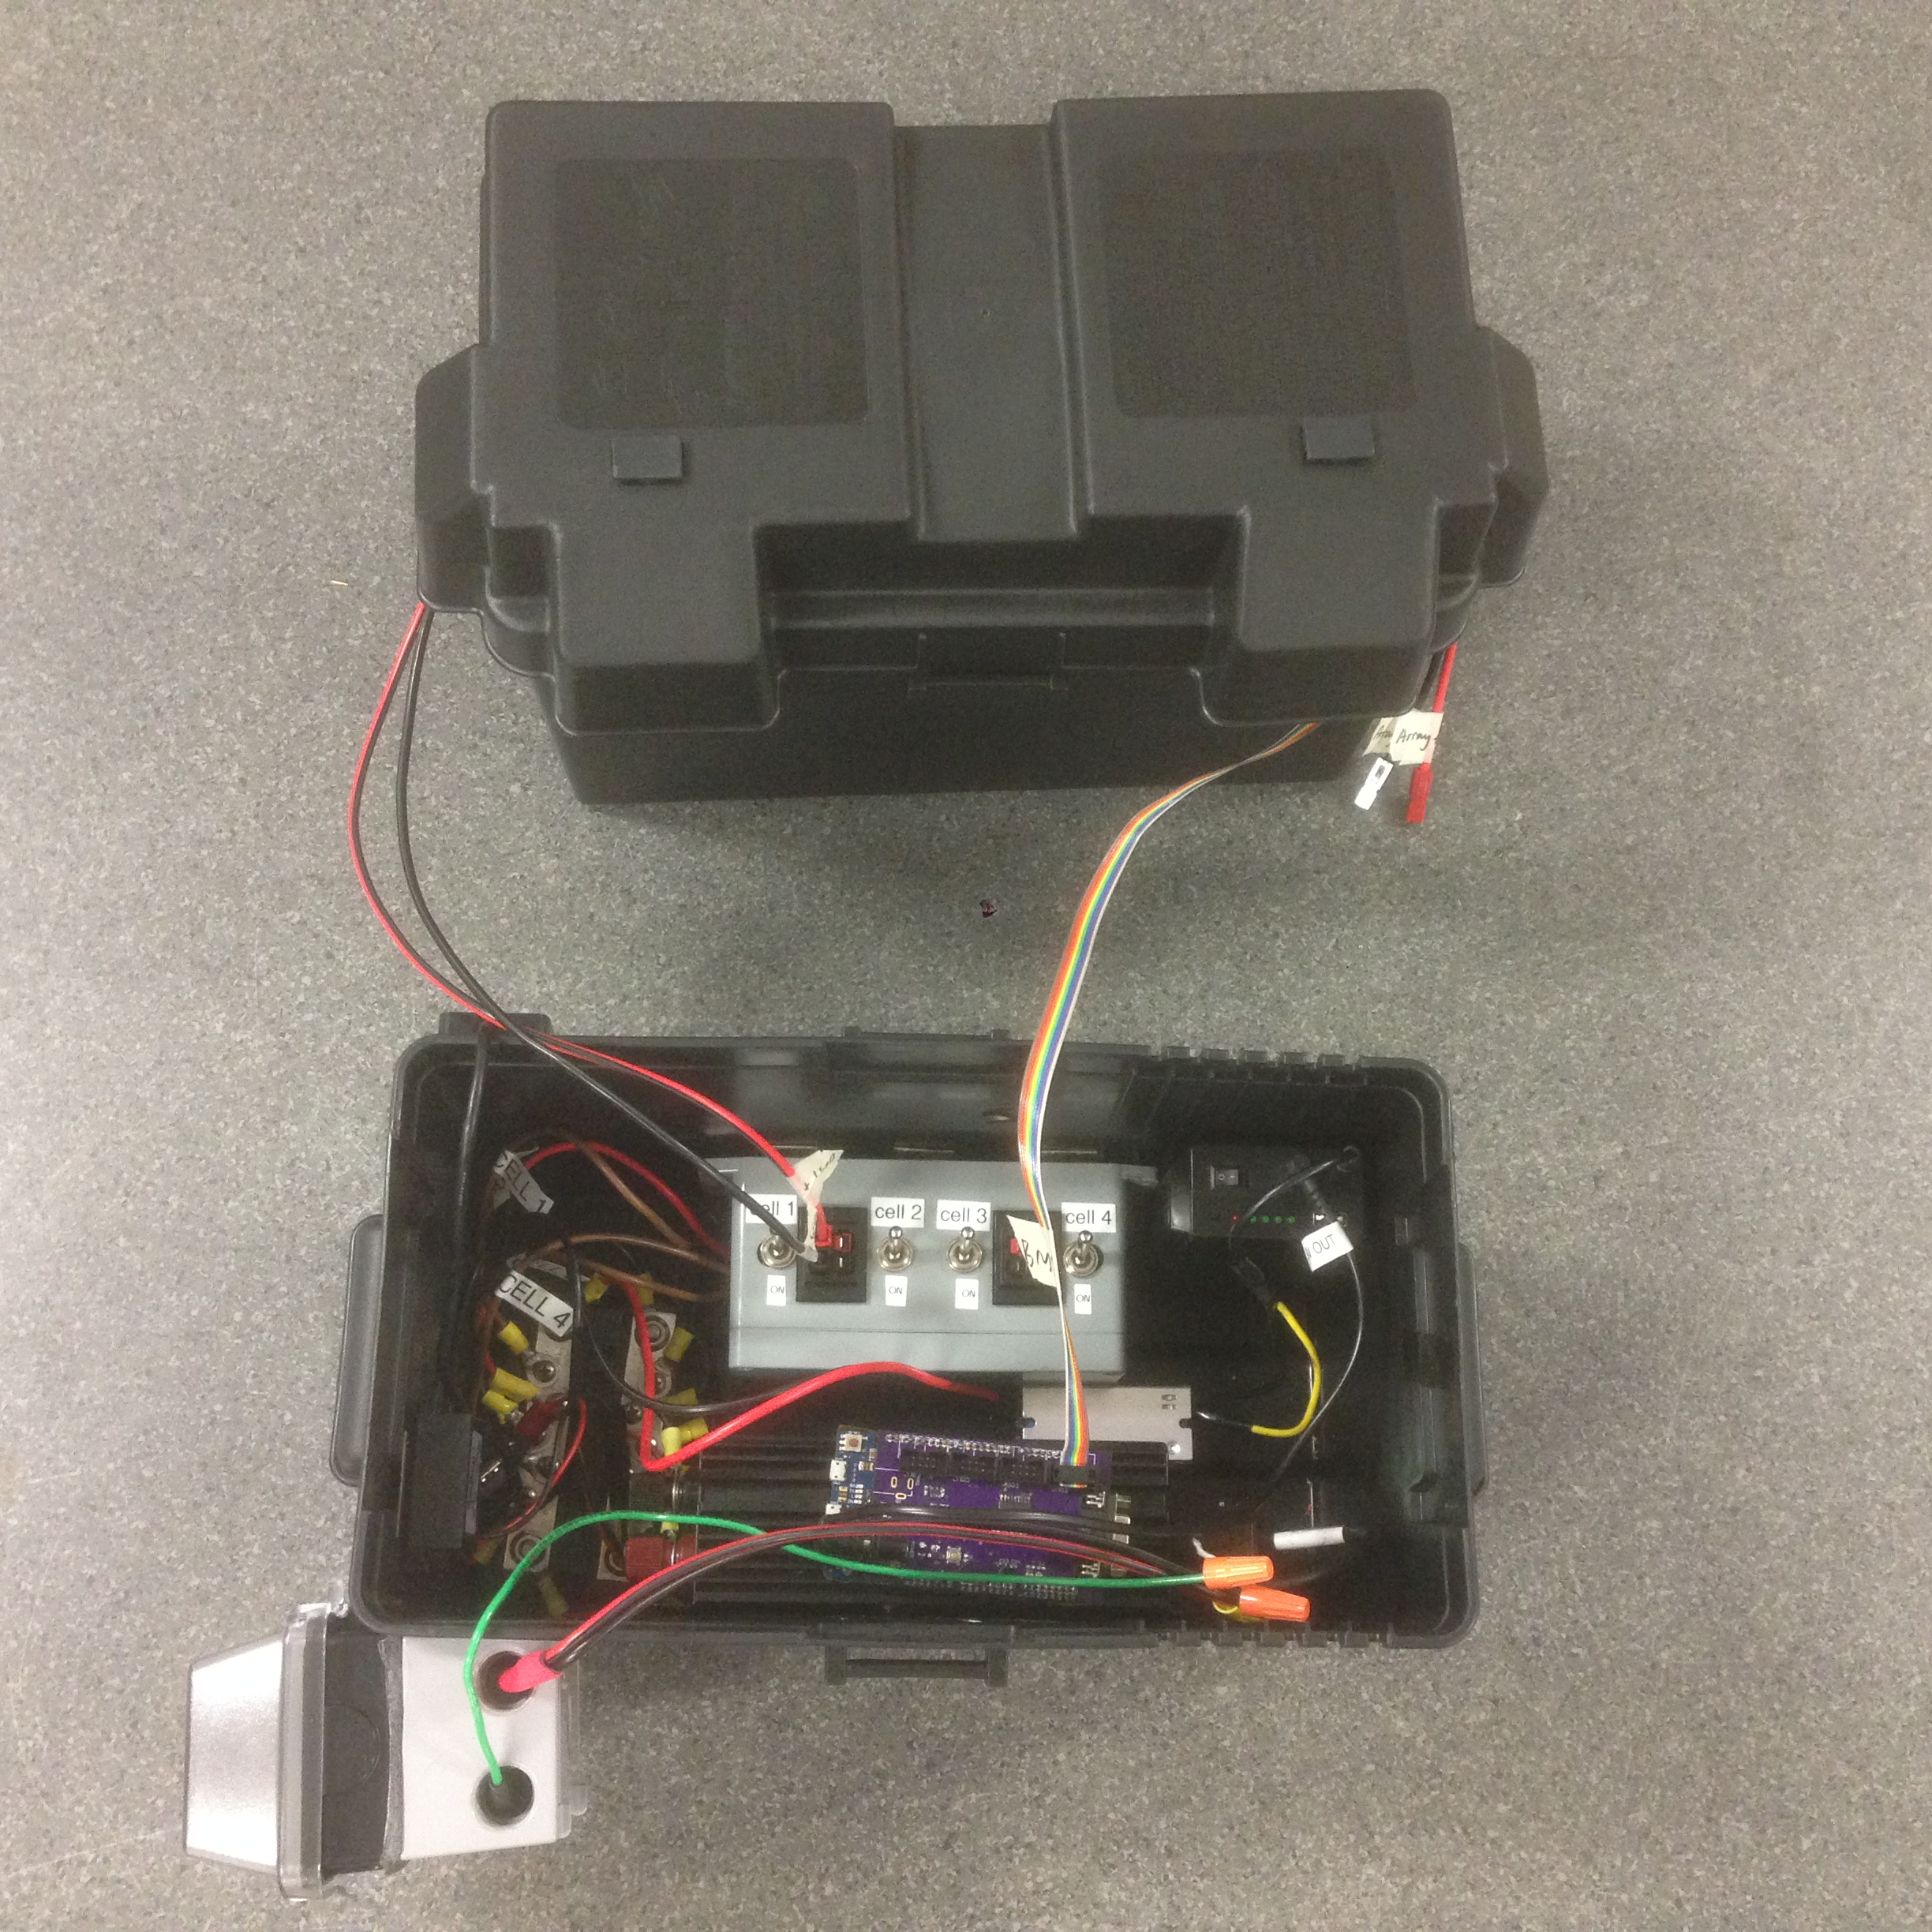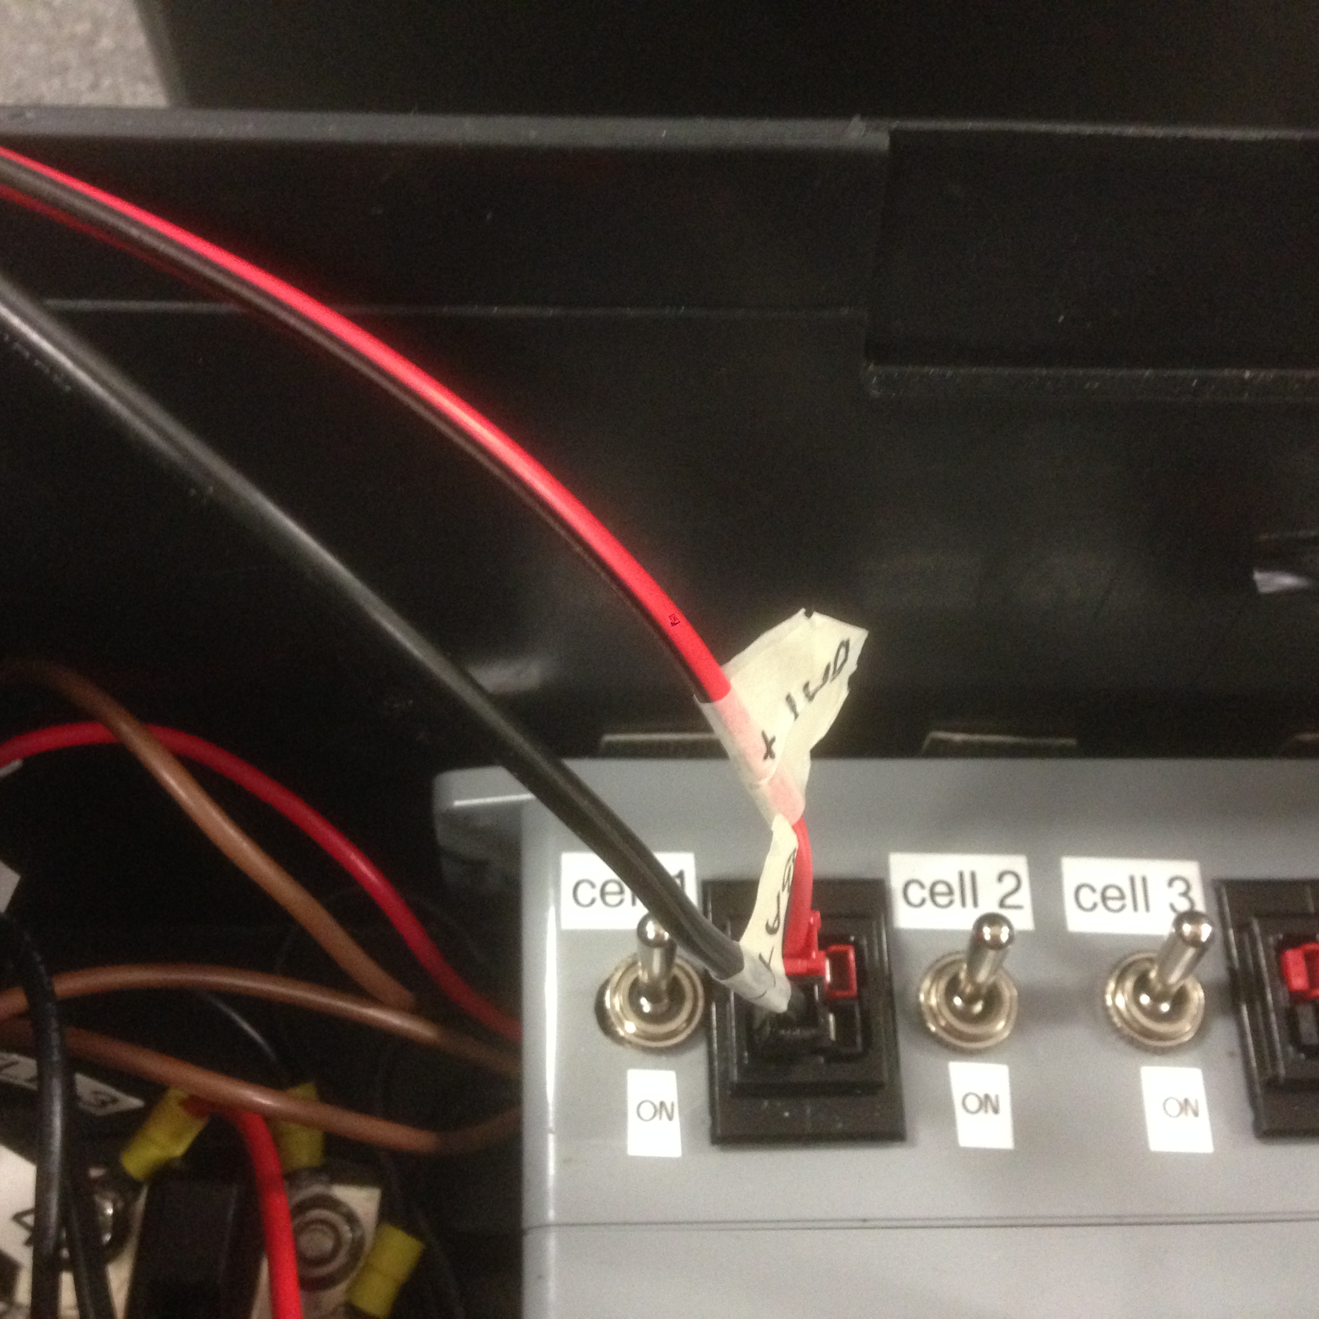

1. Battery box CMU signal output <-> control box BMU board – Ribbon cable

Similarly, four of the connections should be made. In the schematic, is the blue wire that’s denoting the bus.

*On Schematic*

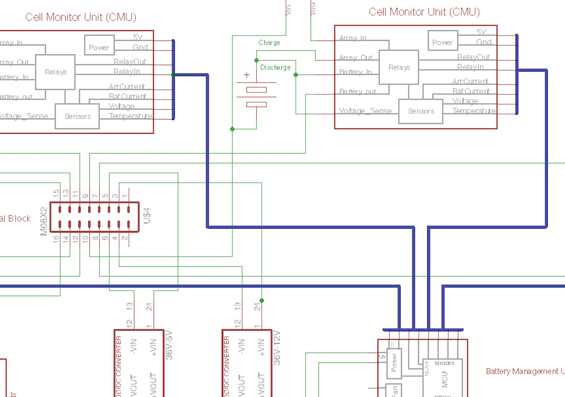

*In Picture*

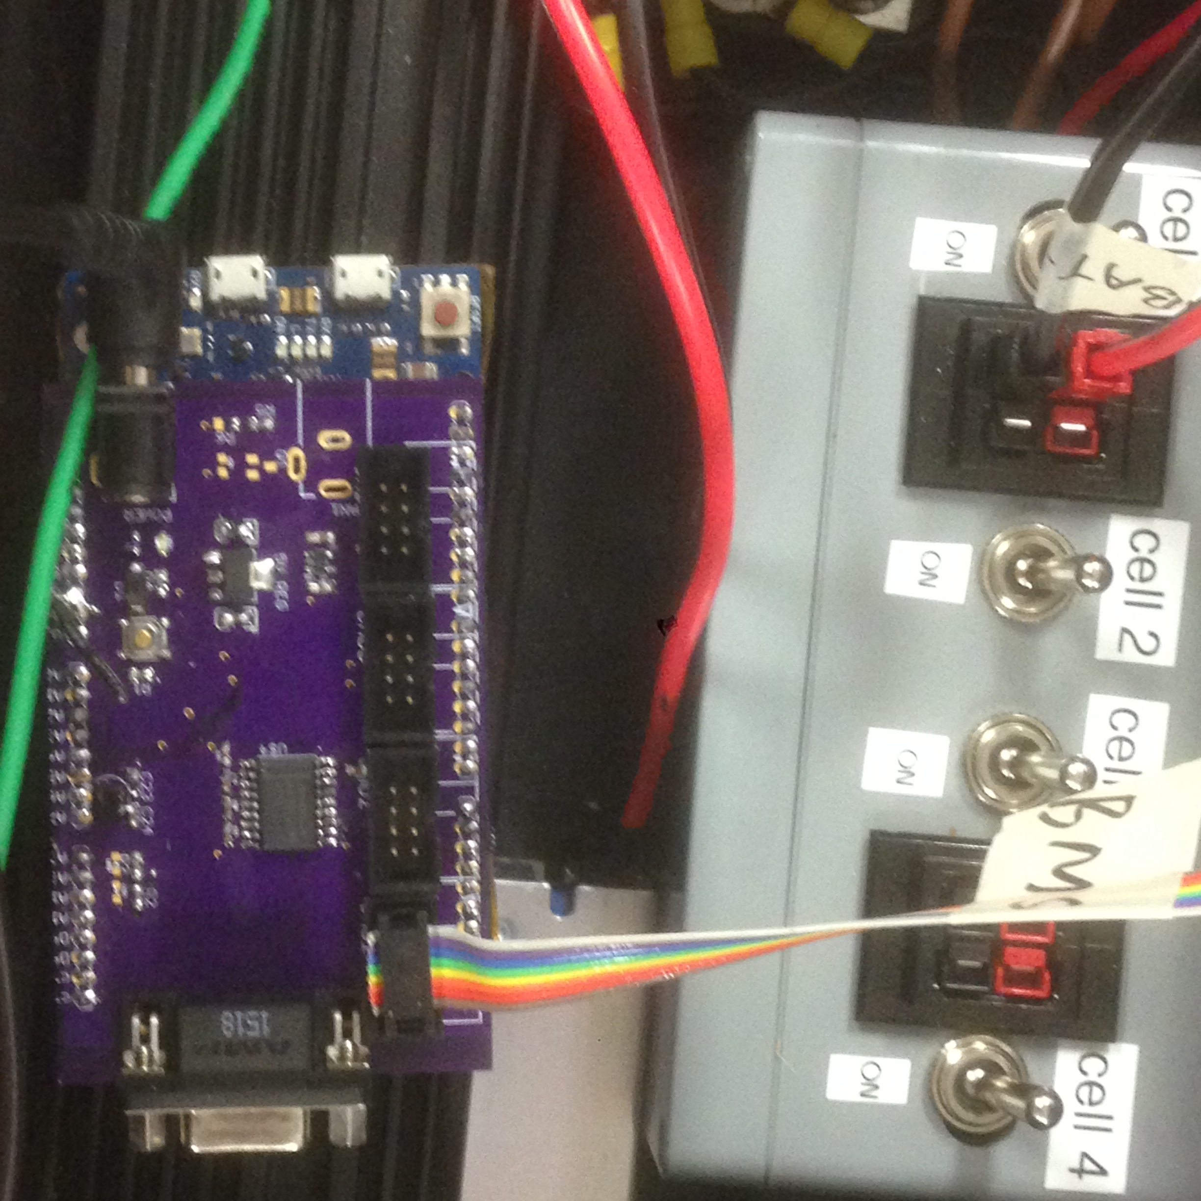

1. Central Control box to screen: BMU board to Screen board – RS232 (DB9) cable

*On Schematic*

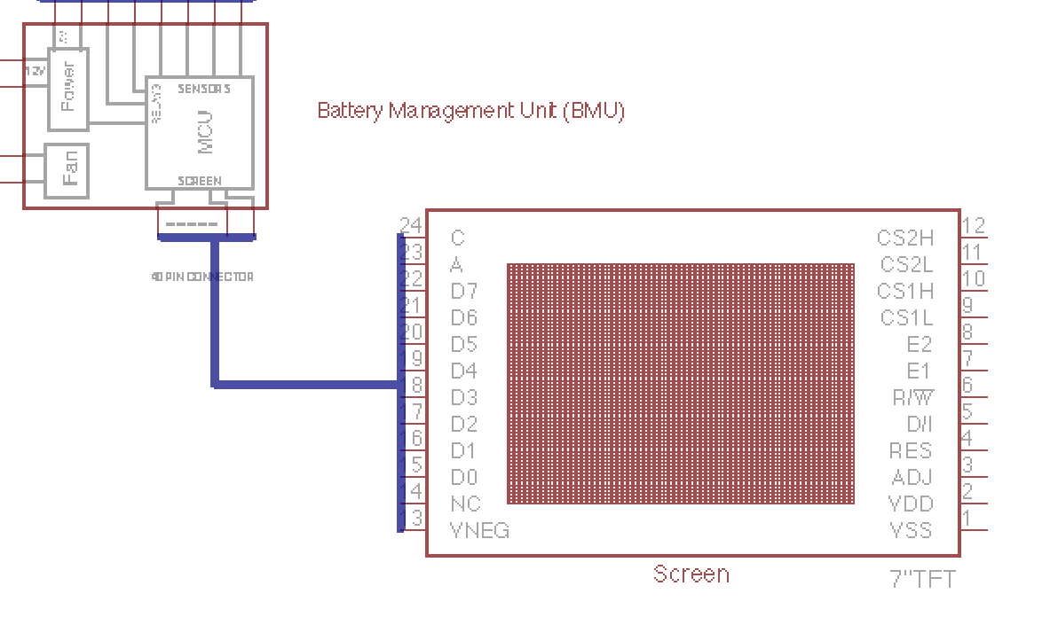

*In Picture*

1. Control box 5v output to USB port on the trunk - USB extension cable.

In actual installation, a USB extension cable will be used to connect to the final location on the trunk.

*On Schematic*

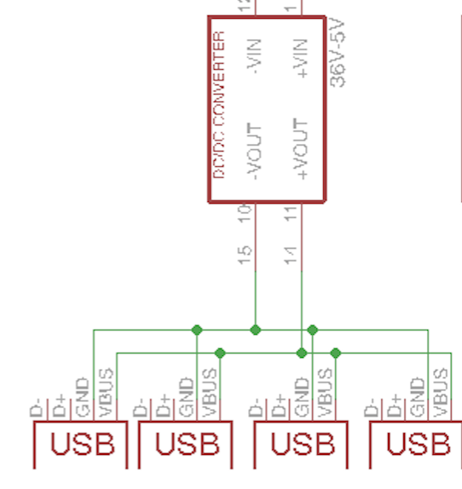

*In Picture*

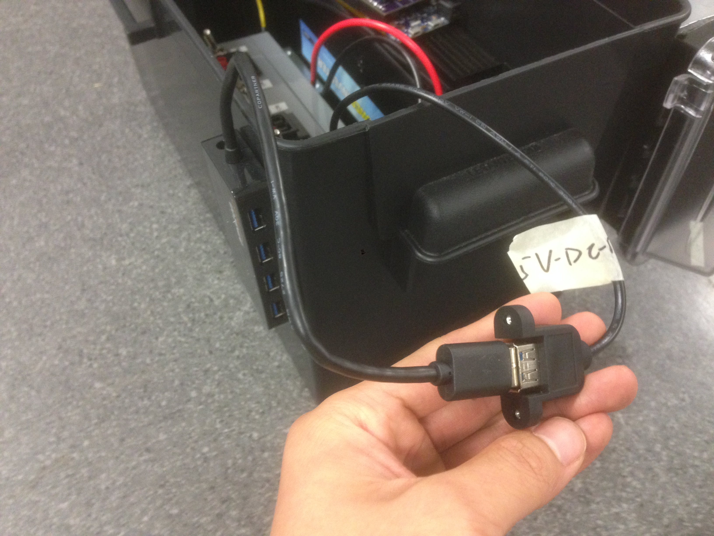

1. Control box inverter output to AC outlet - AC extension cable.

Similar to the USB hub, an extension cable will be used for connecting the inverter to the AC outlet during actual installation. Suggest high voltage / weather proof connectors to be used. (in this example picture, we are using the cap connector for easy connect and disconnect).

*On Schematic*

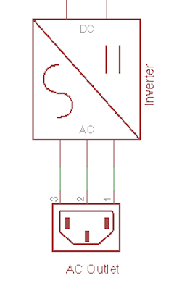

*In Picture*

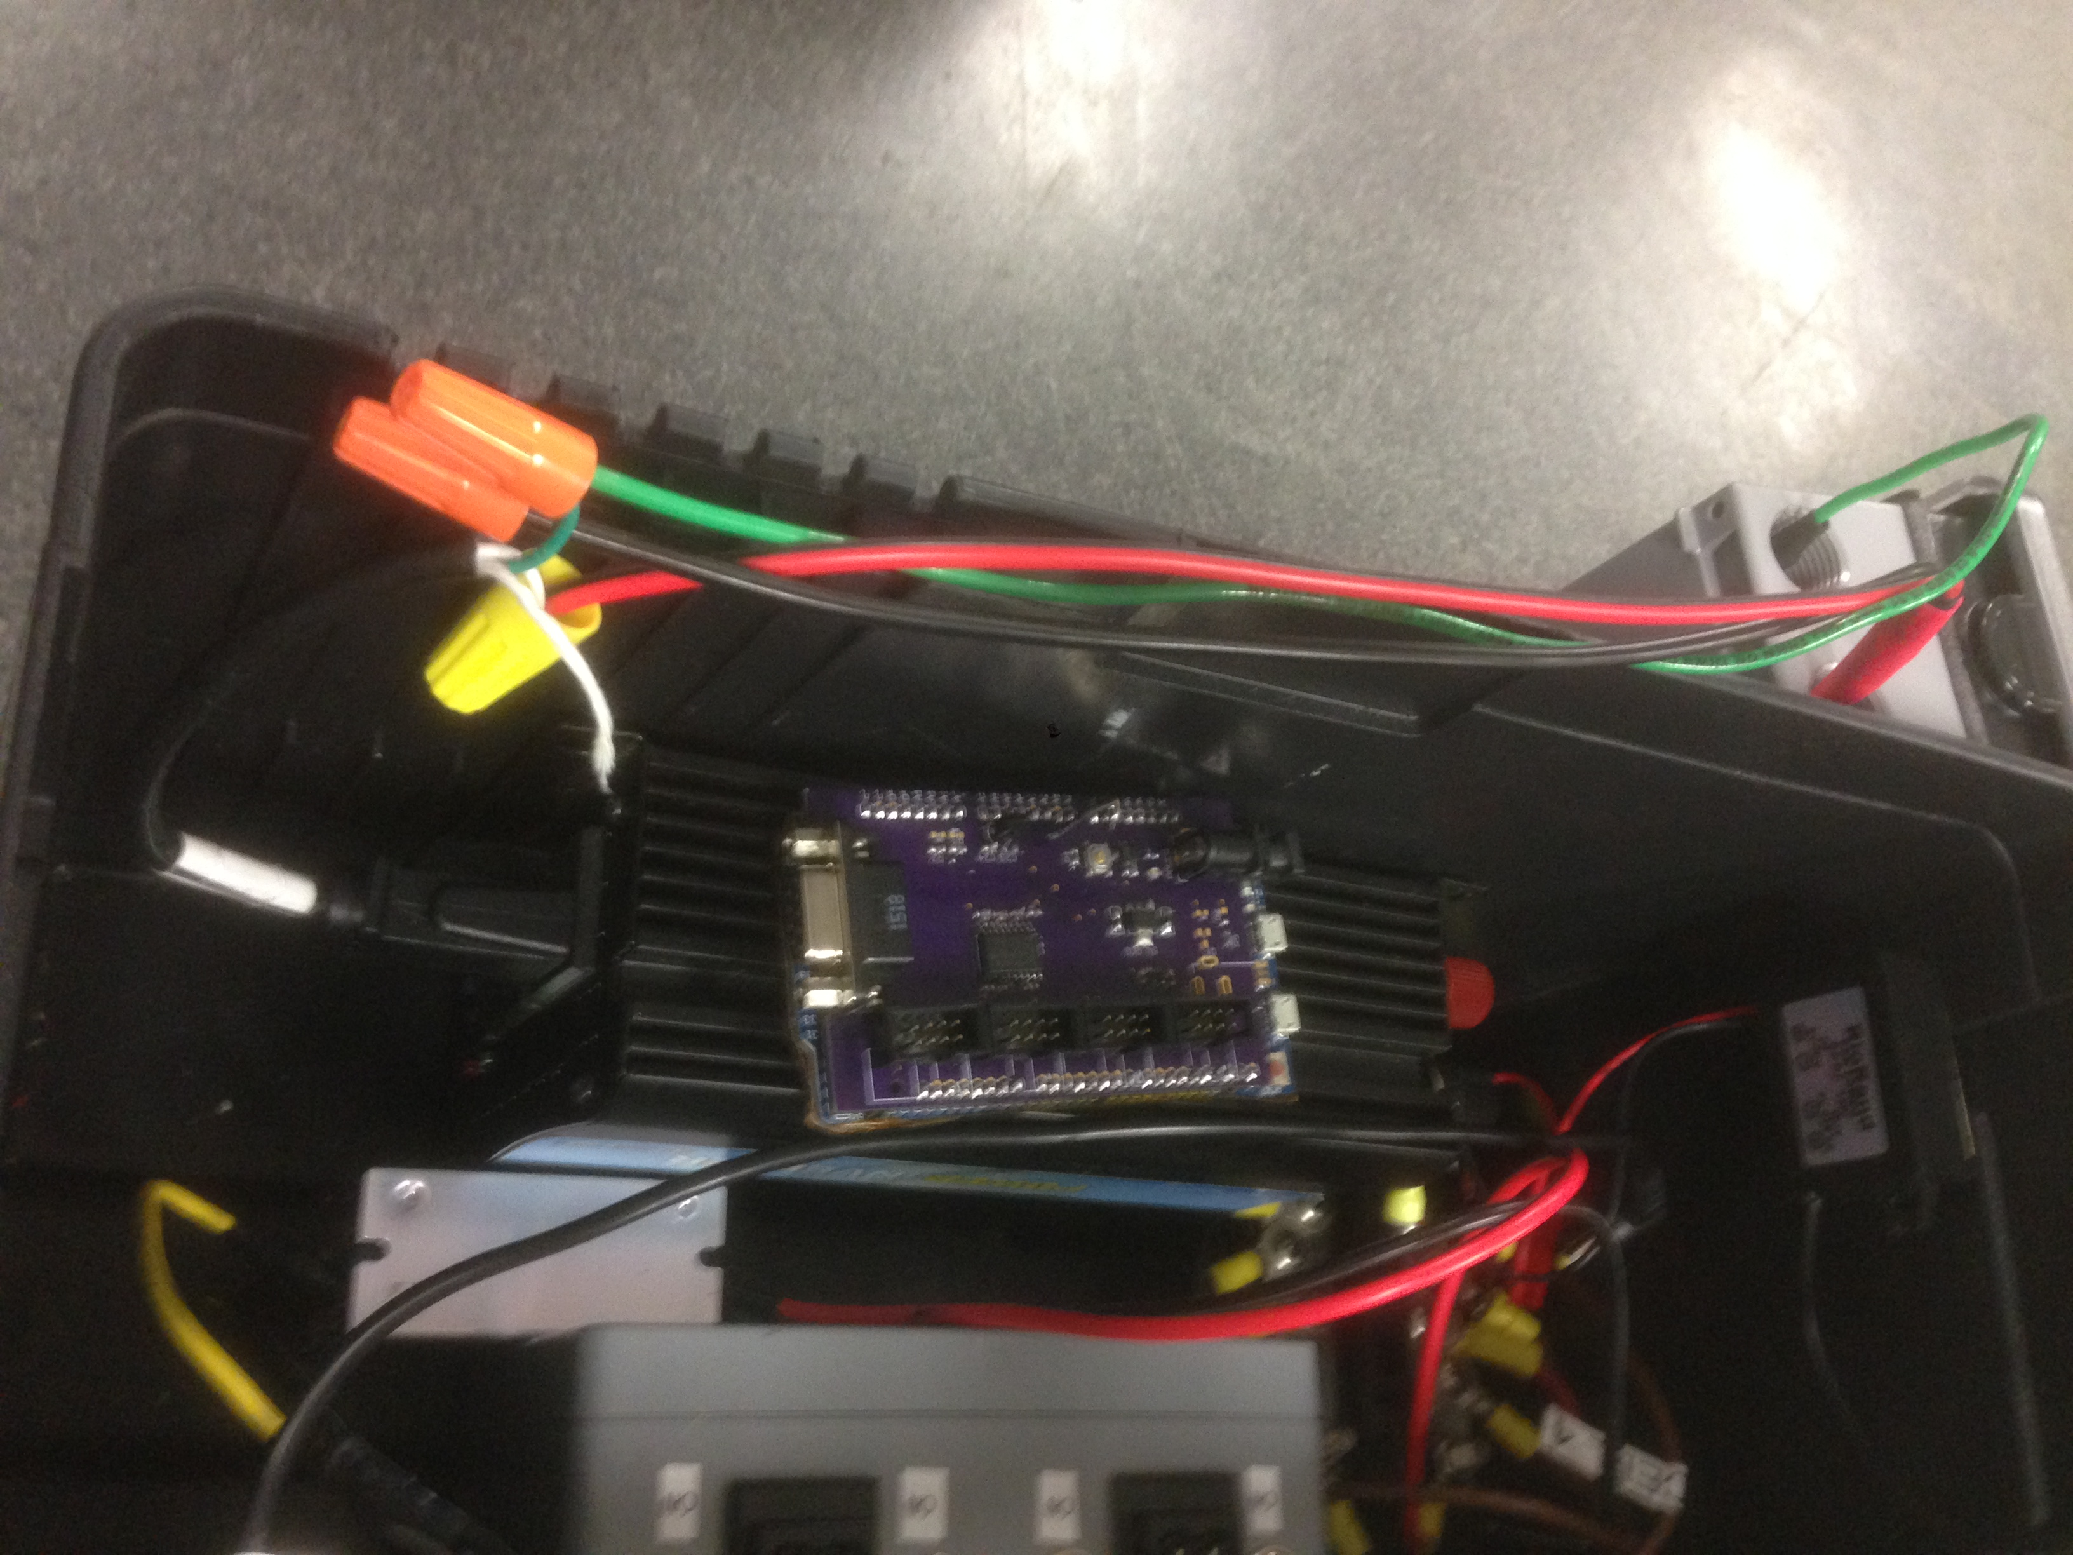

2.2. Weather Proof and Insulation

2.2.1. Solar Panel Junction Box: During installation, make sure the lid of the solar panel junction box is screwed in:

[Picture]

2.2.2. Battery box: After wiring, make sure the lid of the battery box is closed:

[Picture]

2.2.3. Wiring Raceway: Wirings between battery box and control box, solar panel and battery box should be shielded with conduit.

2.2.4. AC Outlet: When installing the AC outlet, make sure the weatherproof lid is opened the right direction

[Picture]

2.3. Grounding

After finished wiring of the whole system, proper grounding can be achieved by connection the ground rod to the negative terminals of the terminal block. It tied the battery ground, charge controller ground, solar panel ground and all the power electronics ground and output device ground together and should be tied to earth ground at the very end.

[Picture ]